|  |  |
| --- | --- |
|  | FPT ACADEMY INTERNATIONAL  FPT – APTECH COMPUTER EDUCATION |

Centre Name: ACE-HCMC-2-FPT.

Address: 590 Cach Mang Thang 8, District 3, Ho Chi Minh City, Viet Nam.

**[Zara Therapy Clinic]**

|  |  |  |
| --- | --- | --- |
| Supervisor: | Phạm Thị Lánh | |
| Term: | 1 | |
| Batch No: | T1.2203.M1 | |
| Group No: | 5 | |
| Order: | Full name | Roll No. |
| 1. | Lê Việt Hải Dương | Student1373756 |
| 2. | Hà Thiện Nhân | Student1373765 |
| 3. | Trần Đức Lợi | Student1373760 |
| 4. | Nguyễn Văn Nghiệp | Student1373766 |

Month 07 Year 2022

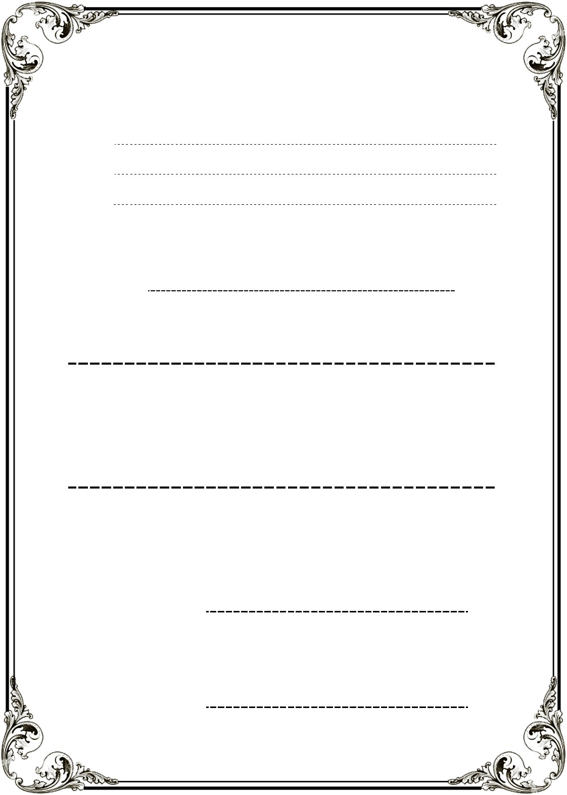This is to certify that

**Mr. LÊ VIỆT HẢI DƯƠNG**

**Ms. HÀ THIỆN NHÂN**

**Mr. TRẦN ĐỨC LỢI**

**Mr. NGUYỄN VĂN NGHIỆP**

Have successfully Designed & Developed

**ZARA THERAPY CLINIC**

Submitted by: **Ms. PHAM THI LANH**

Date Of Issue: July, 2022

Authorized Signature:

# Content

Content 4

Acknowledge 5

Synopsis 6

REVIEW 1 7

Problem Statement 8

Customer Requirements Specifications 10

Architecture and Design of the project 11

Site map 12

Screen shots 13

I. Homepage 13

II. Quick Information 14

III. Therapists Information 15

IV. Client testimonials/Reviews 16

V. Contact Form 17

VI. Site Footer 18

VII. Products Pages 19

Task Sheet 20

REVIEW 2 21

Task Sheet 30

Testing document 30

Final checklist 32

# Acknowledge

As we understand that the eProject is a step-by-step learning environment that closely simulates the classroom and Lab based learning environment into actual implementation. It is a project implementation at your fingertips!! An electronic, live juncture on the machine that allows you to.

✓ Practice step by step i.e., laddered approach.

✓ Build a larger, more robust application.

✓ Usage of certain utilities in applications designed by the user.

✓ Single program to unified code leading to a complete application.

✓ Learn implementation of concepts in a phased manner.

✓ Enhance skills and add value.

✓ Work on real life projects.

✓ Give a real-life scenario and help to create applications more complicated and useful.

✓ Mentoring through email support.

We would like to send a great thank to our professor and others student for the adorable support during the time in the project.

Beside several mistakes we had made in the project, we hope to have more opportunities to widen our knowledge in the web developing world.

We also thank you so much for your information and the “demo” project from India APTECH to help us get more reality experience in this project. Since we have gained more experience from this project, we will not stop learning anything as much as we can to be more successful in the future.

Your Sincerely,

Team Group 05.

# Synopsis

- The Objective of this program we aim is to give a sample project to work on real life projects. These applications help us build a larger, more robust application.

- The objective is not to teach us HTML/JavaScript but to provide us with a real life scenario and help us create basic applications using the tools.

- Hence, we can revise the chapters before we start with the project.

- This project The Objective of this program is to give a sample project to work on real life projects. These applications help you build a larger, more robust application.

- The objective is not to teach you the software but to provide you with a real-life scenario and help you create basic applications using the tools.

- You can revise the topics before you start with the project.

- This project is meant for students who have completed the module of HTML5.

- These programs should be done in the Lab sessions with assistance of the faculty if required.

- The website (in this project) is a tool that help the company to access the

international market and gain more and more new customers.

- It is very essential that a student has a clear understanding of the subject.

# REVIEW 1

## Problem Statement

At **Zara Therapy Clinic**, we help a person relieve stress, increase relaxation, improve circulation and gain relief from pain by manipulating the muscle and tissues in the body. They help rehabilitate injuries through touch and aid in the general wellness of a patient.

One of the most important marketing tasks one needs to complete is getting a website built for the respective services. Although a website by itself will not bring new clients to your practice, it will be very difficult to generate new clients online without a proper website strategy. Search engine optimization and advertisement can be used to expand your practice for long-term success once a website strategy is properly developed. Hence you need to develop a website for a therapist which will provide complete details about the services.

**Requirement Specification:**

The Web site is to be created based on the following requirements.

1) The Home Page should be created making use of Sections with a suitable logo, the header section can be added which will show images of therapies/demo sessions.

2) The site must contain the links to navigate through any category for the information.

3) The site should display a menu which will contain the options for brief introduction about the various therapists available, contact details and any other information if required.

4) There should be list of related products and services. The products may include essential oils, lotions and few helping machines and accessories.

5) Various services should be categorized as per the technique/medical aid/beauty aids etc.

6) Apart from all above there should be sections like

- Gallery :High quality, premium images make the website aesthetically pleasing and provide a visual context for the products or services that the business trades in

- Client testimonials/Reviews: Along with just text reviews, Video testimonials are also an effective ways.

- An About us page

- Educational Information (About Therapies)

- Offers and discounts

Should also be included in website

7) There should be a “Contact Us” page which will have the Address of the stylist which should be displayed using GeoLocation API (eg. GoogleMaps) and the email address which when clicked will invoke the local mail client from where they can send an email.

## Customer Requirements Specifications

|  |
| --- |
| HARDWARE / SOFTWARE REQUIREMENT: |
| Software:  ● Notepad/HTML editor  ● Dreamweaver/Javascript |
| Hardware:  ● A minimum computer system that will help you access all the tools in the courses is a Pentium 166 or better  ● 64 Megabytes of RAM or better |

## Architecture and Design of the project

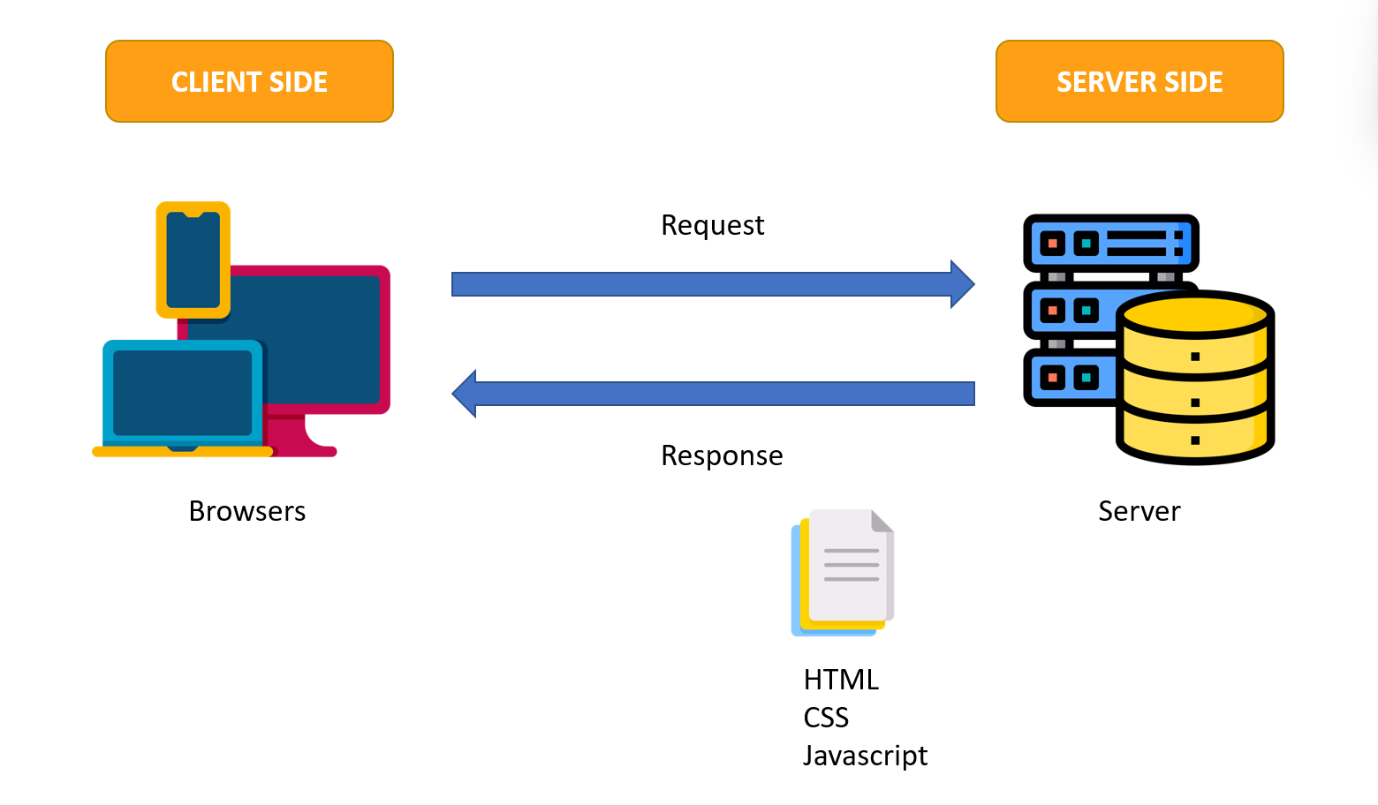

## Site map

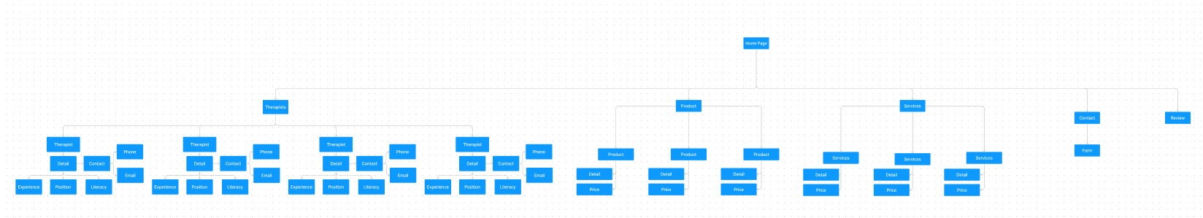–

## Screen shots

### Homepage

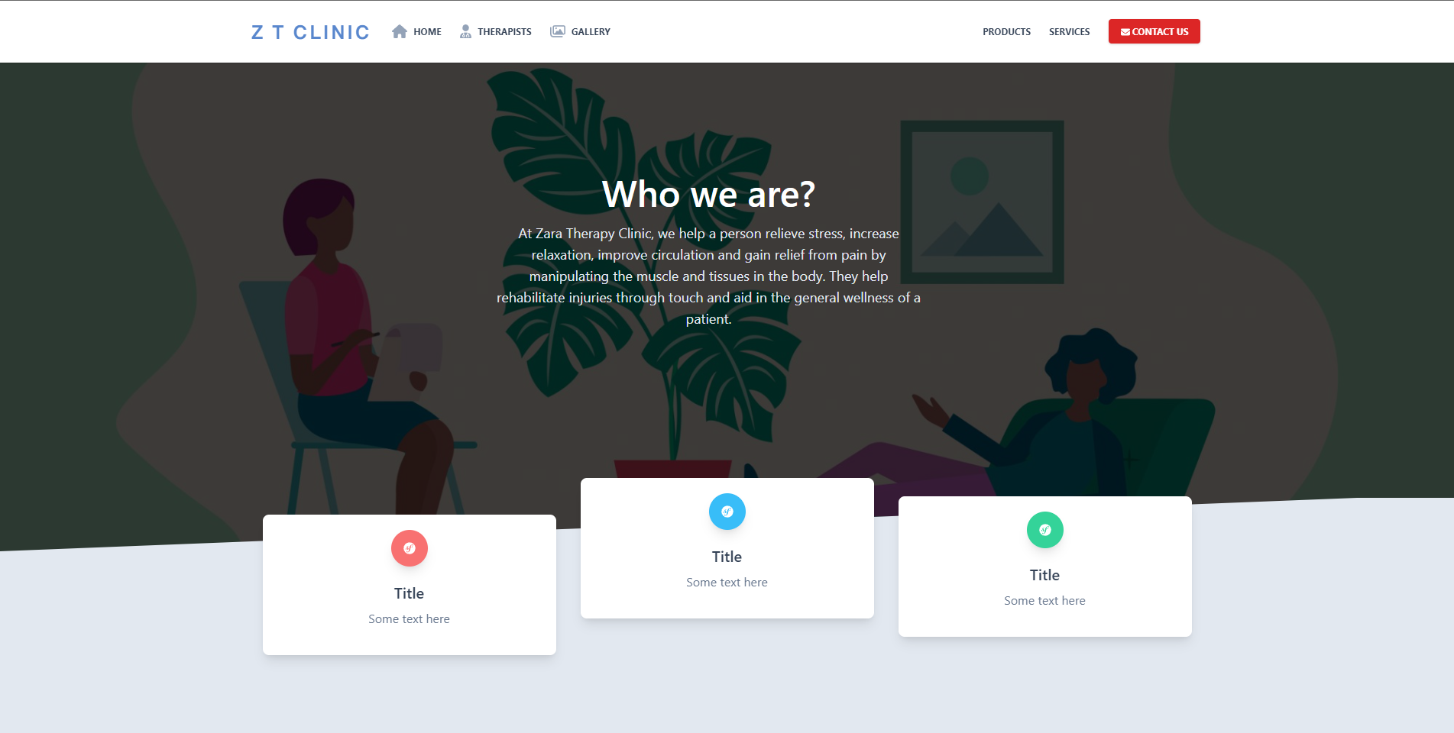

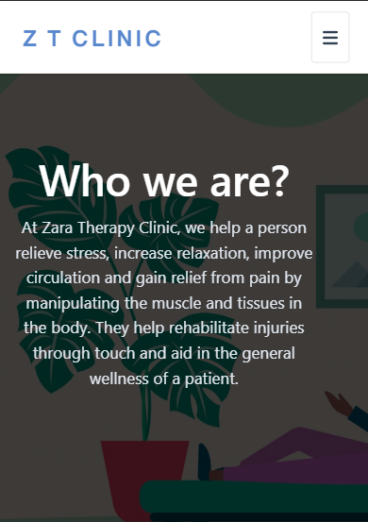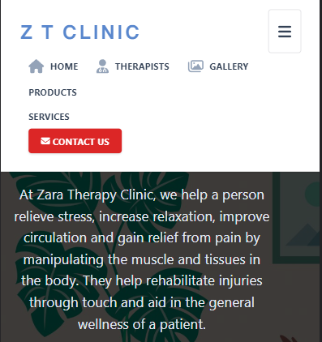

**Description:** This is a homepage of Zara Therapy Clinic, the top of this page is a header, after that is a navigation bar. The main part of a homepage beside the introduce also includes 3 textbox to show a small interesting introduce about the Zara Therapy Clinic. The website will also work almost perfectly with the mobile interface

### Quick Information

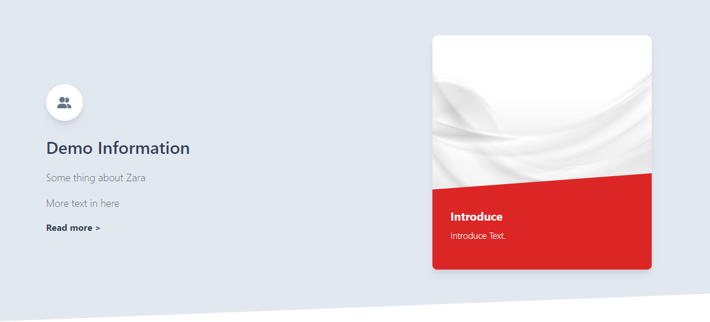



**Description:** This section for show some infomatin about the Zara Therapy Clinic. This section will allow website visitors to see some pictures of Zara Therapy Clinic

### Therapists Information

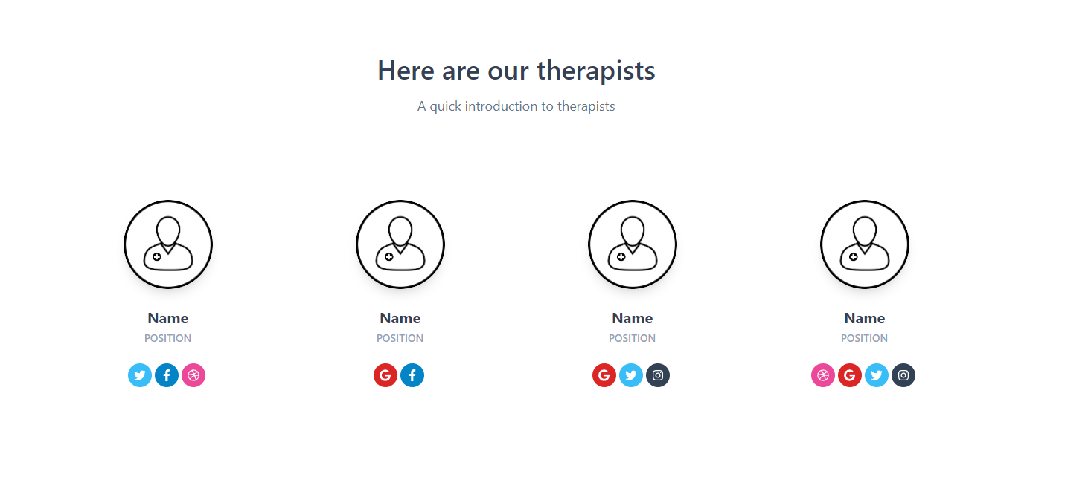

**Description:** This section therapists information. Detail about name, position and contact methods and social network links.

### Client testimonials/Reviews

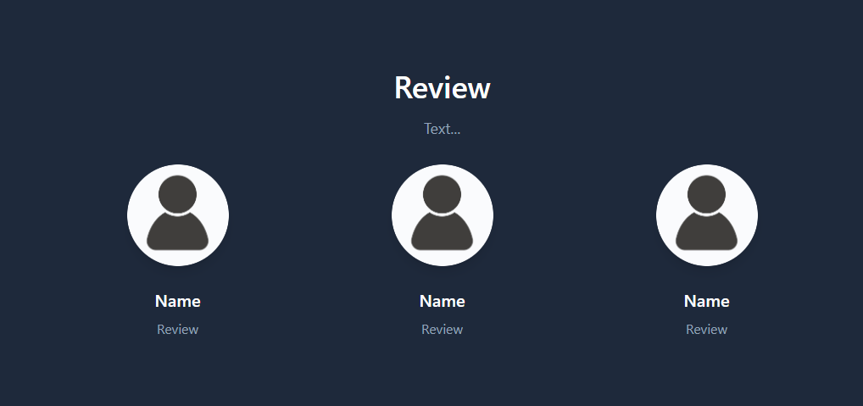

**Description:** A place to display both customer reviews and your own service experiences. This section includes the name and the rating/experience.

### Contact Form

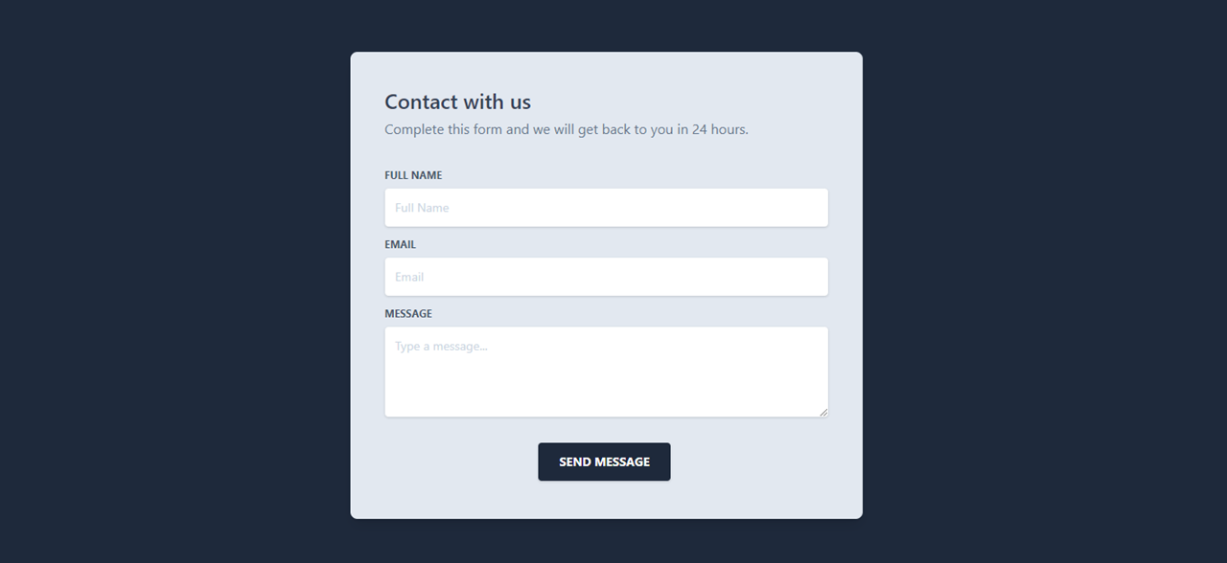

**Description:** Includes a form for users to enter information such as name, email and message to contact Zara Therapy Clinic

### Site Footer

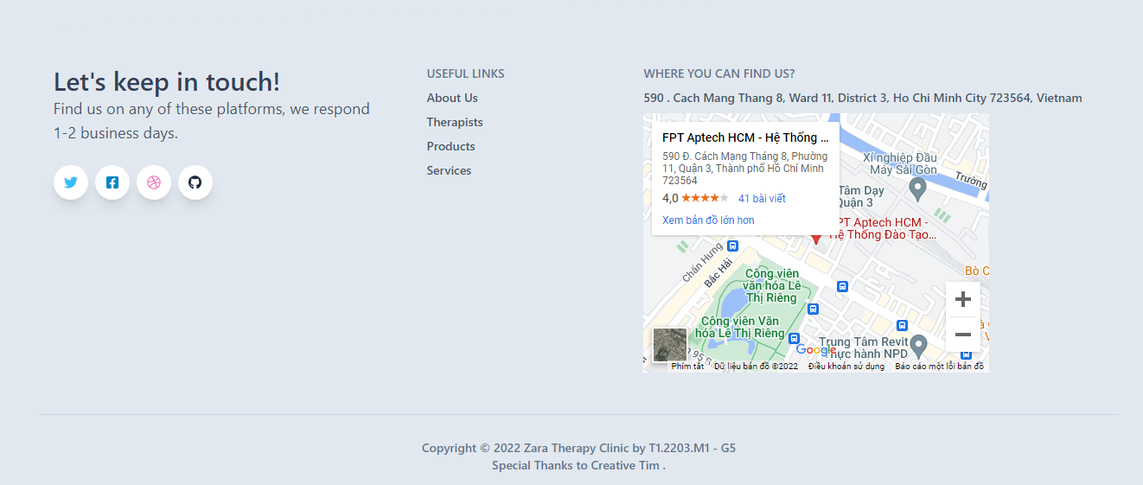

**Description:** Includes social media links, useful links and addresses as well as a navigation map to the address. Next to it is information about the website's copyright.

### Products Pages

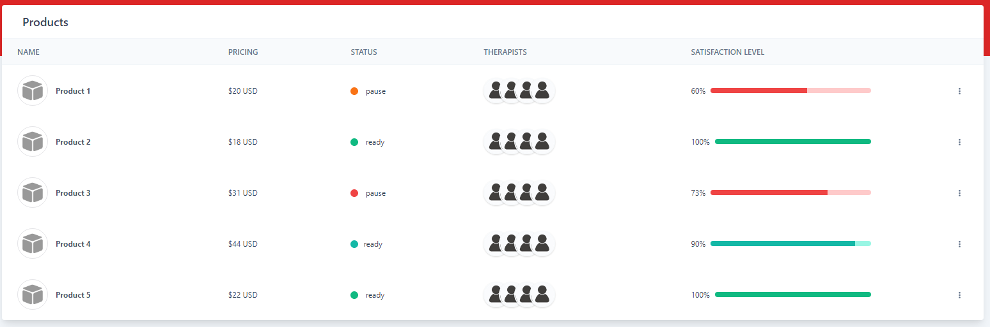

**Description:** This page contains information about products/services available from Zara Therapy Clinic. Include details about the name, price of roducts/services.

## Task Sheet

|  |  |  |  |  |  |  |
| --- | --- | --- | --- | --- | --- | --- |
| **Project Ref No.** | **Project Title – Ask Me Mobile** | **Activity Plan Prepared by** | **Date of preparation of Activity Plan** | | | |
| **Task** | **Actual Start Date** | **Actual Days** | **Teammate Names** | **Status** |
| Brainstorming ideas for layouts and Project Object | | Nhân, Nghiệp, Dương, Lợi | 21/06/2022 | 1 days | Nhân, Nghiệp, Dương, Lợi | Completed |
| Draw site maps and architecture design | | Dương, Lợi, Nghiệp | 22/06/2022 | 1 days | Dương, Lợi | Completed |
| Wire framing general page layout | | Dương | 23/06/2022 | 3 days | Dương | Completed |
| Collect static assets (pictures, mp4, documentation,…) | | Lợi, Nhân, Nghiệp | 26/06/2022 | 5 days | Lợi, Nhân, Nghiệp | Completed |

# REVIEW 2

HOME

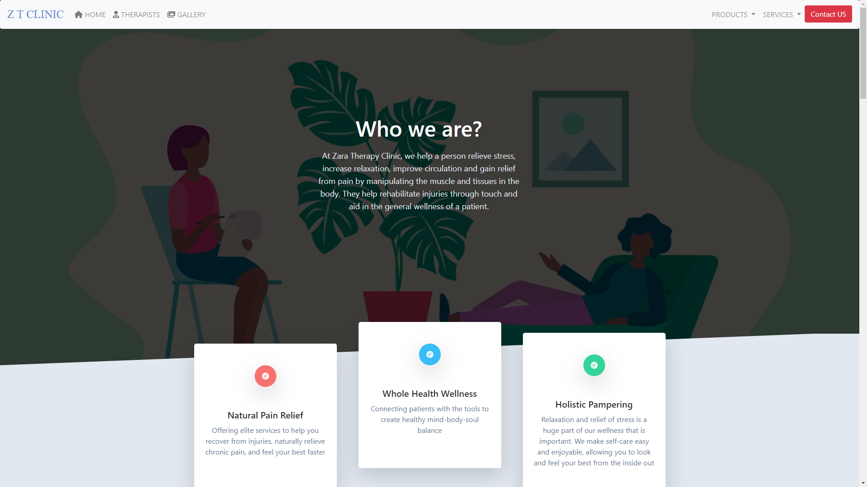

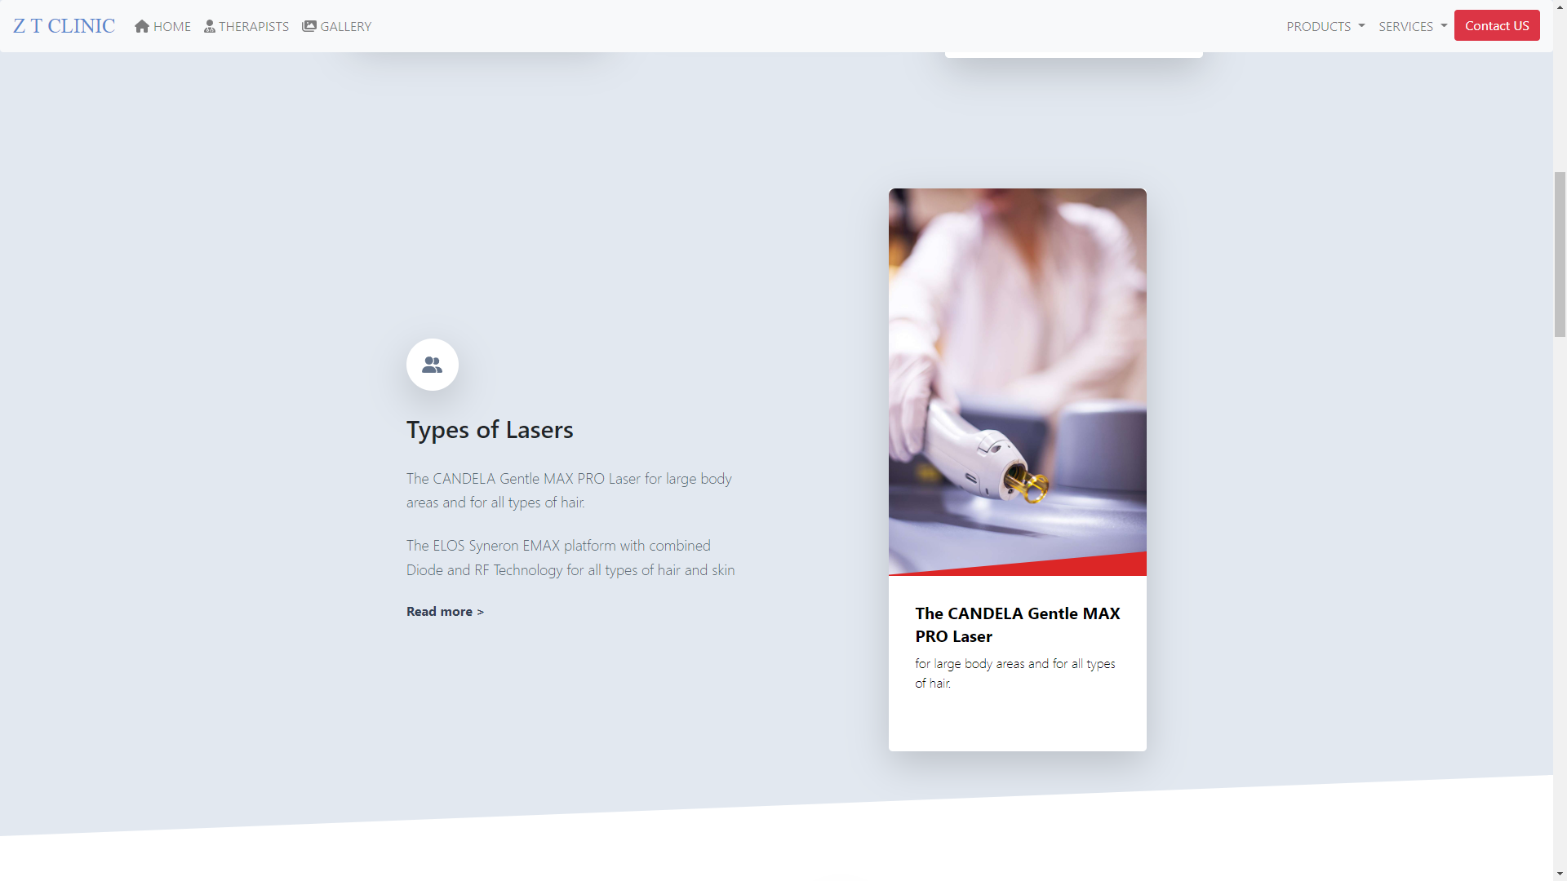

GALLERY  
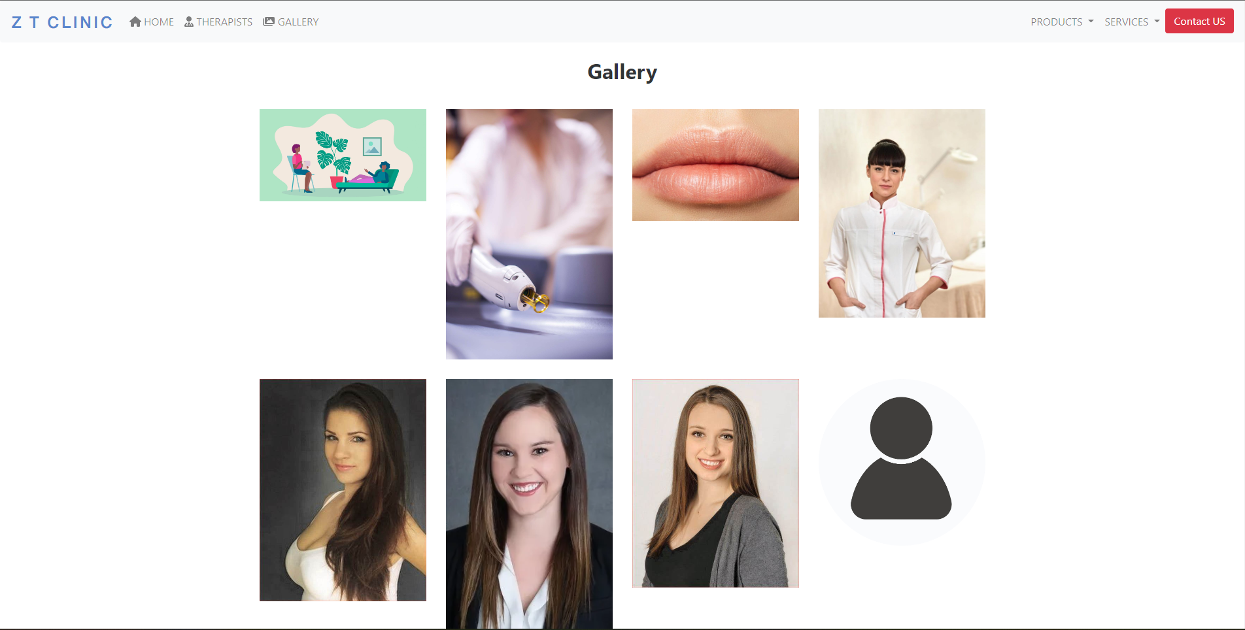

THERAPISTS

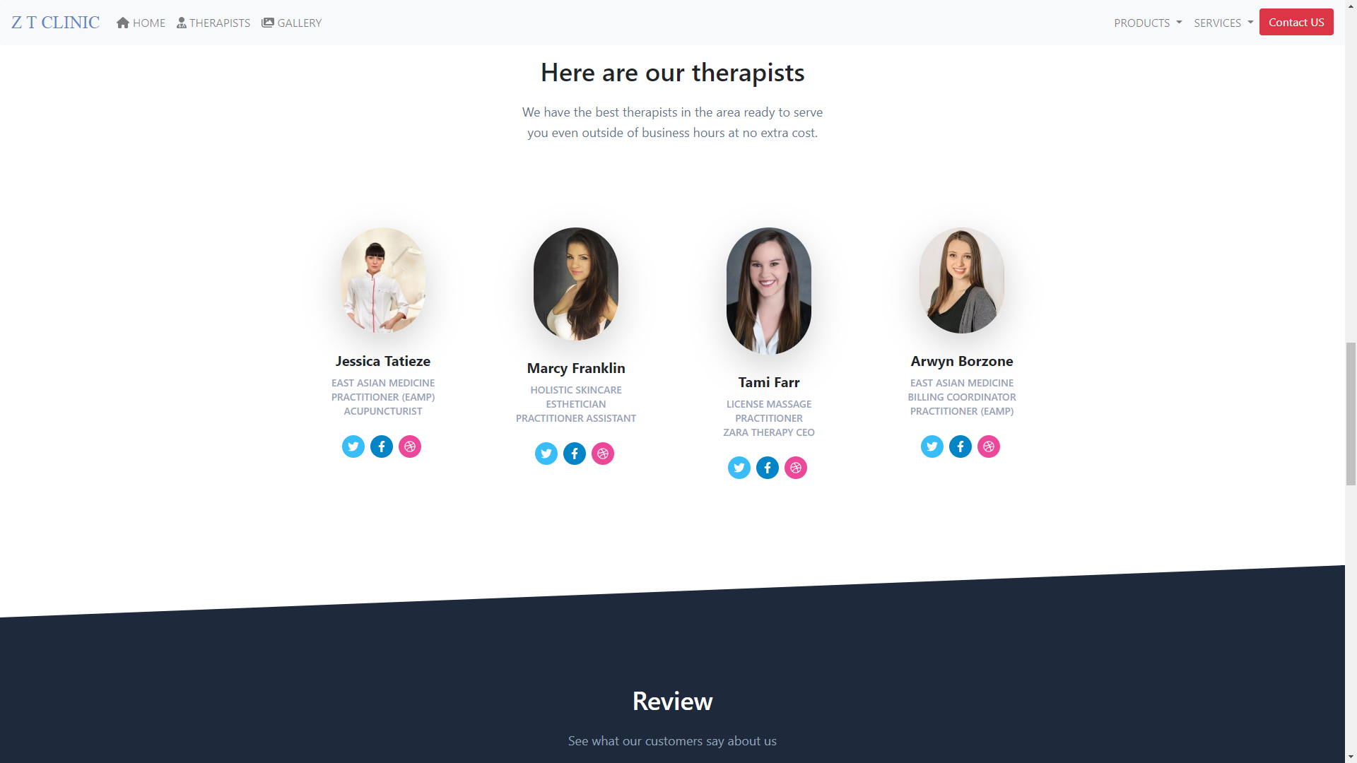

OUR PRODUCTS

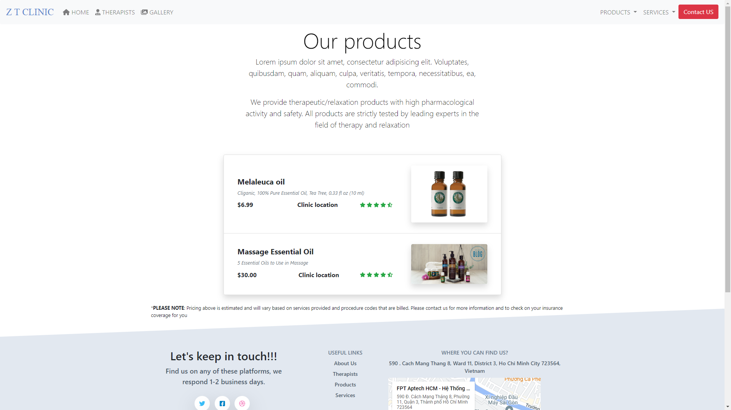

OUR SERVICES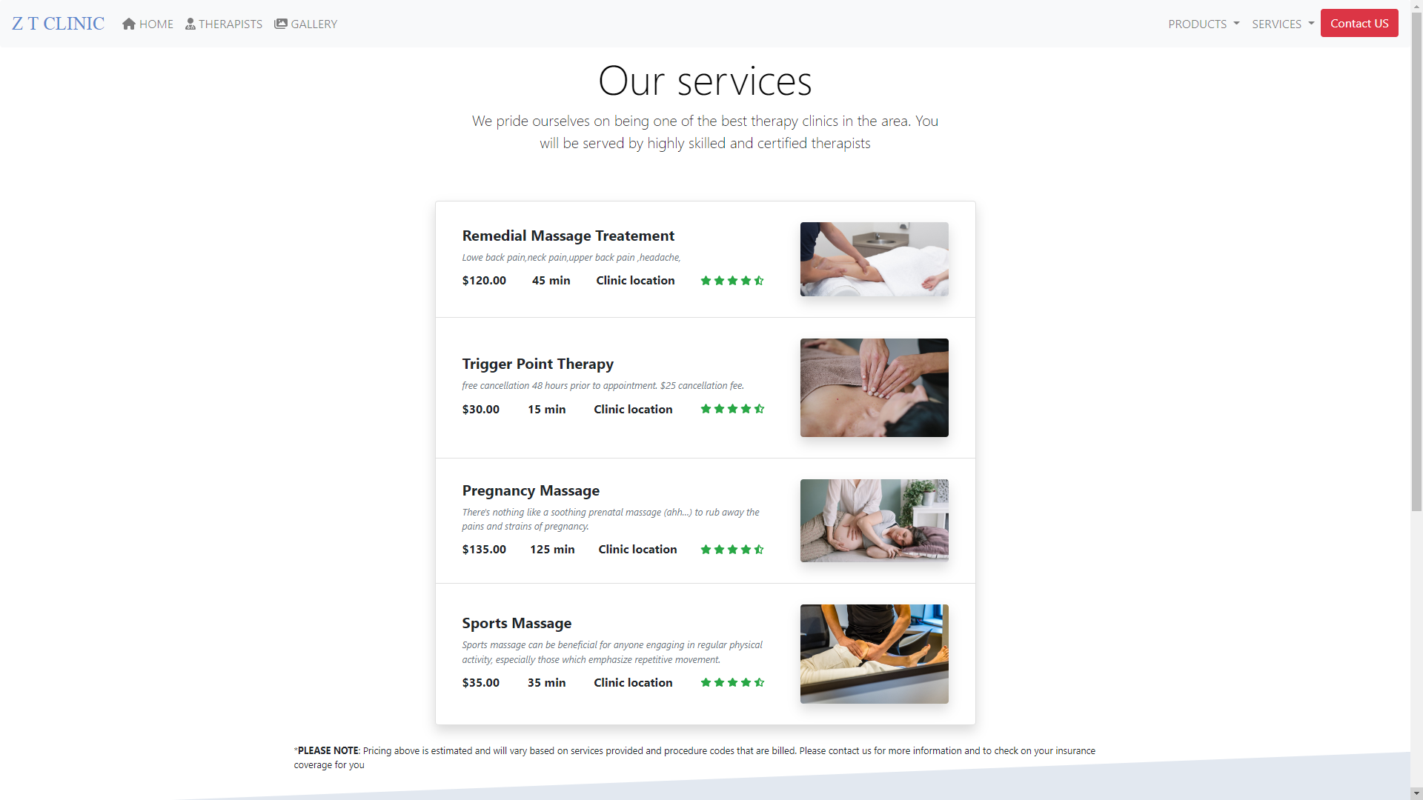

REVIEW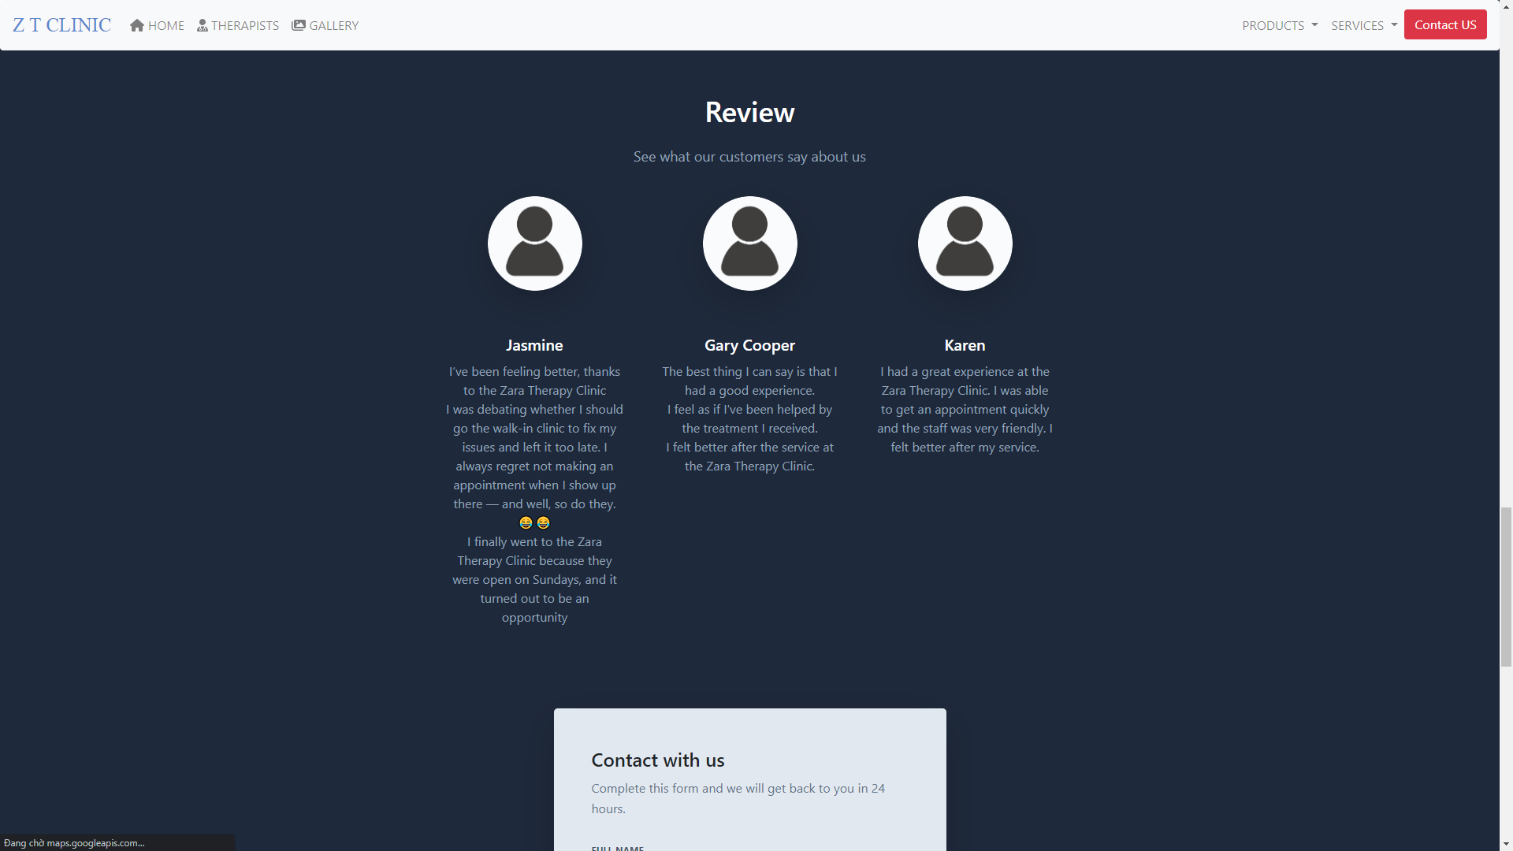

CONTACT WITH US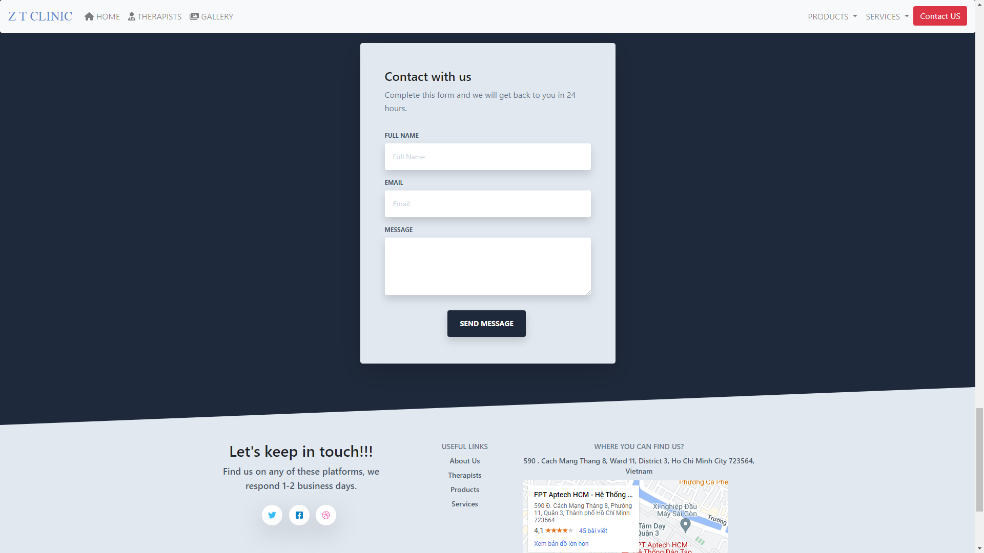

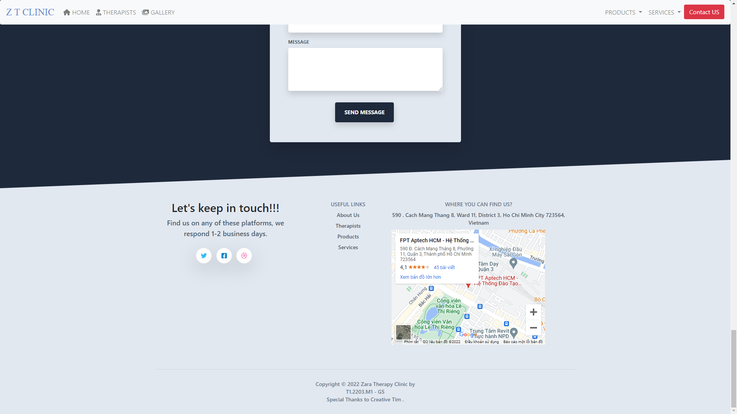

## Task Sheet

|  |  |  |  |  |  |  |
| --- | --- | --- | --- | --- | --- | --- |
| **Project Ref No.** | **Project Title – Ask Me Mobile** | **Activity Plan Prepared by** | **Date of preparation of Activity Plan** | | | |
| **Task** | **Actual Start Date** | **Actual Days** | **Teammate Names** | **Status** |
| Brainstorming ideas for layouts and Project Object | | Dương, Lợi, Nghiệp, Nhân | 11/07/2022 | 1 days | Dương, Lợi, Nghiệp, Nhân | Completed |
| Draw site maps and architecture design | | Dương,  Lợi | 30/06/2022 | 12 days | Dương,  Lợi | Completed |
| Wire framing general page layout | | Dương | 10/7/2022 | 4 days | Dương | Completed |
| Collect static assets (pictures, mp4, documentation,…) | | Nhân ,Nghiệp | 8/7/2022 | 5 days | Nhân ,Nghiệp | Completed |
| Design & Build Homepage | | Dương | 9/7/2022 | 1 days | Dương | Completed |
| Design & Build Sign up | | Nhân | 13/7/2022 | 1 days | Nhân | Completed |
| Design & Build Product Pages | | Dương | 18/7/2022 | 3 days | Dương | Completed |
| Design & Build Product Detail | | Dương | 21/7/2022 | 1 days | Dương | Completed |
| Design & Build Contact | | Lợi | 15/7/2022 | 2 days | Lợi | Completed |
| Design & Build About | | Lợi | 18/7/2022 | 2 days | Lợi | Completed |
| Write Project Report | | Dương | 25/7/2022 | 2 days | Dương | Completed |

## Testing document

|  |  |  |  |  |
| --- | --- | --- | --- | --- |
| **Sr.No** | **Features Tested** | | | **Remarks** |
| 1 | Are all the users able to view the images and links? | | | OK |
| 2 | Have all the views, modules and controllers been | |  | OK |
| properly integrated and is the site function as a single | | |
| page application? | |  |
| 3 | Are the GUI content devoid of spelling mistakes? | | | OK |
| 4 | Is the application user-friendly? | | | OK |
| 5 | Is the Website launching correctly in all popular | |  | OK |
| browsers? |  |  |
| 6 | Are all the forms validated with proper criteria? | | | OK |
| 7 | Do all text links lead to the appropriate website? | | | OK |
| 8 | Do all image links lead to the appropriate website? | | | OK |
| 9 | Are all the images and links clearly visible on the page? | | | OK |
| 10 | Does the Web page work properly in all the tested | |  | OK |
| browsers? |  |  |
| 11 | Does the Web page take too long to be loaded fully? | | | OK |
| 12 | Is the navigation sequences correct through all the Web | | | OK |
| pages on the site? | |  |
| 13 | Is the JavaScript code working as expected in all click | | | OK |

## Final checklist

|  |  |  |  |  |
| --- | --- | --- | --- | --- |
| **Sr.No** | **Features Tested** | | | **Remarks** |
| 1 | Are all the users able to view the images and links? | | | OK |
| 2 | Have all the views, modules and controllers been | |  | OK |
| properly integrated and is the site function as a single | | |
| page application? | |  |
| 3 | Are the GUI content devoid of spelling mistakes? | | | OK |
| 4 | Is the application user-friendly? | | | OK |
| 5 | Is the Website launching correctly in all popular | |  | OK |
| browsers? |  |  |
| 6 | Are all the forms validated with proper criteria? | | | OK |
| 7 | Do all text links lead to the appropriate website? | | | OK |
| 8 | Do all image links lead to the appropriate website? | | | OK |
| 9 | Are all the images and links clearly visible on the page? | | | OK |
| 10 | Does the Web page work properly in all the tested | |  | OK |
| browsers? |  |  |
| 11 | Does the Web page take too long to be loaded fully? | | | OK |
| 12 | Is the navigation sequences correct through all the Web | | | OK |
| pages on the site? | |  |
| 13 | Is the JavaScript code working as expected in all click | | | OK |